Language Learning App Design Document

The aim of this app is to make learning under-documented languages easier to learn remotely through making this available to anyone with a CC license.

The purpose of this app is to replicate the ‘Dirty Dozen’ (DD) activity of Total Physical Response (TPR). The DD is a simplified version of TPR used to learn a group of new vocabulary words, usually around 12 (hence dozen, but can go up to 20). These words can be names of objects, verbs or other concepts depicted in pictures. The app will play a recorded sound that is associated with a flashcard. The user then will attempt to select the correct associated card. Upon correct selection, the app will flash the card with a green border and move to the next randomly selected card from the bunch.

The app should implement some sort of database in the background to track words and DD configurations. It would be nice if ANKI would be able to use the database as well.

Please note that layout examples are just that – example mock-ups I made in word, so can be adjusted. I have no experience with app design and very little with python – so am open to all suggestions. Thanks! The other file I have attached is an excel file that I made that does a similar task, but does not have the recording / playing audio component.

**Home Screen**:

Settings

New Session

Load

Dictionary

New Session. Open to Learning App Layout (Blank)

Load. Show previously saved DD’s. Lets you select one to load into the app for study.

Dictionary. Open to Dictionary Screen  
Settings. Open the Settings Menu.

**Learning App Layout (Blank):**

(+)

Clear

Load

Save

Create Card

(-)

(#/#)

Randomize!

Repeat

Reveal

Introduce

Home

PD

Button Explanation:

Create Card. Opens the ‘Create Card’ screen

(+) Shows one more Card, plays that card sound (even if previous card has not been clicked on). If there is no more cards, brings up the ‘Create Card screen’

(-) Shows one less Card.

(#/#) . Will show the number of cards shown and the total number of cards (Number of cards shown / Total number). The number of cards shown should be editable.

PD. Stands for ‘Picture Dictionary.’ Reveals All Cards in order, and starts to play their associated sound one at a time. As sound is played, the card is highlighted.

Randomize! Rearranges the cards on screen in a non-overlapping random manor. The plays a sound associated with one of the cards (chosen randomly).

Repeat. Repeat the sound that was played associated with a card.

Reveal. Highlights the correct card by creating a glowing green border around it for 1 second.

Introduce. Highlights the most recently added card. Plays the sound associated with the card several (a number set in settings) times.

Save. Opens the Save Dialogue

Load. Opens dialog to load previously saved cards. Given option to clear current cards or add cards to selction.

Clear. Clears cards on screen.

Home. Goes to Home Screen.

Example of App with Cards shown:

(+)

Clear

Load

Save

Create Card

(-)

11/11

Randomize!

Repeat

Reveal

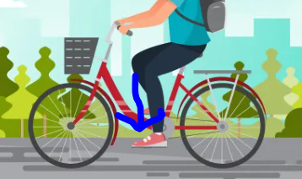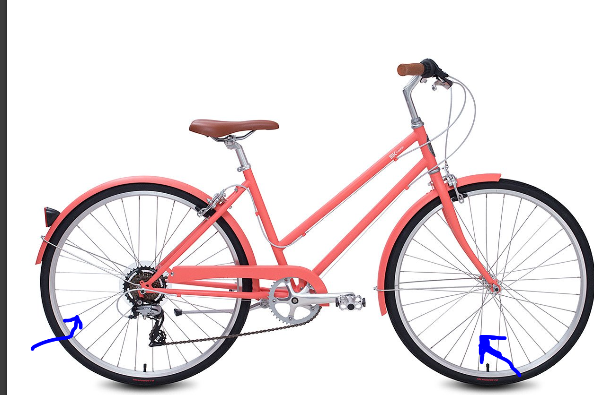

(+)

Clear

Load

Save

Create Card

(-)

11/11

Randomize!

Repeat

Reveal

水

国

你

哈

的

皮

大

了

Cards

**Create/Edit Card:**

English:_______________________

Local Language:_______________________

🎤

▶

Picture

Save

Clear Picture

(All options are non-obligatory)

English: Enter English word or definition here

Local Language: Enter local language here (ideally can handle any character).

🎤- Click on this to record the sound

▶- Click on this to play the recorded the sound

Picture: Allow pictures to be pasted in

Clear Picture: Removes the current picture

Save. Saves the card to the dictionary. Closes window.

**Dictionary**

Create New Entry: Opens the Create Card box.

Create New DD



|  |  |  |  |  |  |  |
| --- | --- | --- | --- | --- | --- | --- |
| **Index** | **English** | **Local Language** | **Recording** | **Picture** | **Times Reviewed** | **Times Correct** |
| **1** |  |  |  |  |  |  |
| **2** |  |  |  |  |  |  |
| **3** |  |  |  |  |  |  |
| **4** |  |  |  |  |  |  |
| **…** |  |  |  |  |  |  |

Create New DD: Opens a dialogue to select entries from the dictionary and then loads those into the learning app.

English, Local language should be editable. The dictionary should be scrollable. The columns English, Local Language, Times Reviewed, Times Correct should be sortable.

When clicking on a recording, it should play the recorded sound.

When clicking on the Index number, the Create/Edit Card box should appear for that entry allowing editing of the recording or picture.

**Create New DD**

Save

|  |  |  |  |  |  |  |  |
| --- | --- | --- | --- | --- | --- | --- | --- |
| ☑ | **Index** | **English** | **Local Language** | **Recording** | **Picture** | **Times Reviewed** | **Times Correct** |
| **☐** | **1** |  |  |  |  |  |  |
| **☐** | **2** |  |  |  |  |  |  |
| **☐** | **3** |  |  |  |  |  |  |
| **☐** | **4** |  |  |  |  |  |  |
|  | **…** |  |  |  |  |  |  |

**☐** This tick mark should be checkable. The checked options will be the ones that are added to the DD.

Save. Opens the Save dialogue.

**Save Dialogue**

This should be a simple dialogue that give the user to name their DD. Then an option to go to the learning screen or to the home screen

Save Name:________________________________

Home

Learning Screen

**Settings**:

(#) Number of times a card is played when introduced.

**☐** Play associated sound again after correct choice?

(Picture/Local language) Show the Picture or Local Language?

(Nothing/English/Local Language) Reveal the English or Local Language on Screen?

(Random/Modified Random) Random will play cards in random order. Modified Random play new cards more often

(Number) Number of times a card is played when introduced.

(Checkbox / Toggle) Play associated sound again after correct choice? (This toggles if the app plays the sound again after the card is correctly selected)

(Picture/Local language) Picture or Local Language? (This toggles between the app showing the picture or the local language)

(Nothing/English/Local Language) Reveal the English or Local Language on Screen? I have not illustrated this on the document elsewhere, but something along these lines as all items may not have recordings or the user may want to review reading:

(+)

Clear

Load

Save

Create Card

(-)

(0/1)

Randomize!

Repeat

Reveal

Introduce

Home

PD



自行车

(Random/Modified Random) Random will play cards in random order. Modified Random play new cards more often*

* Random should work as a uniform distribution (i.e. no card is any more or less likely than any other). Modified Random should look consider the number of times a card has correctly been selected in that session and make those cards less likely to come up. It should also not play a card twice in a row. This could be done by weighting the number of correct selections:

|  |  |  |
| --- | --- | --- |
| Card Index number | Correct # of Selections this session | Probability of This card being selected |
| 1 | 10 | .1 |
| 2 | 7 | .15 |
| 3 | 2 | .25 |
| 4 | 0 | .5 |

## Appendix – App Flow (How a user would interact example)

### Example 1 – New User, First time use, Option 1

User opens app, selections New Session:

New Session

Load

Dictionary

They Select Create Card

(+)

Clear

Load

Save

Create Card

(-)

(#/#)

Randomize!

Repeat

Reveal

Introduce

Home

PD

The Create Card screen opens:

(+)

Clear

Load

Save

Create Card

(-)

(0/0)

Randomize!

Repeat

Reveal

Introduce

Home

PD

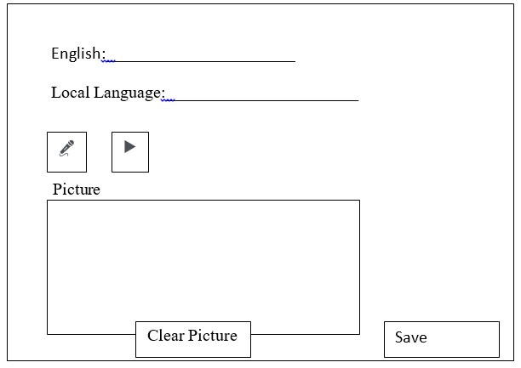

They fill out the information, record an example, listen to the example, paste a picture, and hit save:

English:__Bicycle________

Local Language:______自行车__________

🎤

▶



Picture

Save

Clear Picture

The user can hit Introduce or (+) to show the card:

(+)

Clear

Load

Save

Create Card

(-)

(0/1)

Randomize!

Repeat

Reveal

Introduce

Home

PD

If introduce is clicked, the recording is played (3) times, and as the sound is played, the picture is highlighted.

(+)

Clear

Load

Save

Create Card

(-)

(0/1)

Randomize!

Repeat

Reveal

Introduce

Home

PD



If (+) is selected, the picture is shown, and the sound is played. Nothing happens until the user clicks something else.

(+)

Clear

Load

Save

Create Card

(-)

(0/1)

Randomize!

Repeat

Reveal

Introduce

Home

PD



## 

## Appendix B – Pseudo Code